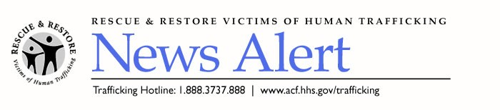

Rescue & Restore Training DVD Available NOW!

The U.S. Department of Health and Human Services team is pleased to announce the availability of the informational Rescue & Restore Victims of Human Trafficking training video. This new campaign resource helps to educate intermediaries, media and the public about human trafficking and provides guidance on how to identify and assist victims.

Every organization in the coalition has been sent one copy of the DVD in a mailing, which should arrive in a week. We encourage you to show the video during conferences, workshops and training sessions that your organization sponsors or attends. This will help in our efforts to continue shedding light on the horrors of human trafficking and to enlist other groups to join our nationwide effort. We also recommend sharing this video with media in your local area to encourage them to run stories on this vital issue.

To view the video online, click on or paste the following URL into your browser:
http://www.myhomefront.tv/media/D0021/video/HTFinalJuly_19_256k.wmv.

If you are interested in receiving an additional copy, please e-mail, please e-mail Lilianne Smith at lilianne.smith@ketchum.com. Based on limited quantities, please request only one additional copy per organization and allow at least two weeks for delivery. If additional copies can be put to good use, contact Gabriel Sanchez-Zinny at gsanchez-zinny@acf.hhs.gov with your needs.

We encourage you to visit the campaign Web site, http://www.acf.hhs.gov/trafficking/, for important updates. In addition, the Web site includes the latest materials order form, which now includes the latest child victims of trafficking and foreign language materials.

###

